FOR IMMEDIATE RELEASE
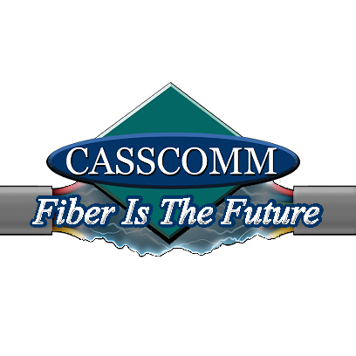
CASSCOMM
Casey French
217-452-4120
Casey.french@casscabletv.com

CASSCOMM Is Moving At EXTREME Speeds To Bring Fiber Optic Services To Central Illinois Communities

VIRGINIA, IL, March 16, 2020 – CASSCOMM is pleased to announce that its broadband deployment construction project -- featuring fiber optic lines running directly into thousands of homes and businesses in central Illinois -- has made substantial progress over the past two years and has targeted the end of 2020 as a key deployment milestone.

Starting in 2018, CASSCOMM in its promise to customers committed to upgrade its network by relying on advanced fiber facilities, considered the future-proof broadband technology that can deliver the fastest Internet speeds on record. CASSCOMM’s effort also represented the company’s dedication to helping close the digital divide in rural America and ensure that children are able to complete online school assignments while at home.

In late 2018, CASSCOMM decided to make the hard, but smart, decision to upgrade its entire footprint to Fiber To The Home (FTTH) services. This technology would not only provide the fiber services to businesses in the area but also to area residents, giving them the ability to get a higher symmetrical Internet speed, digital phone services, and IPTV, also known as CASSCOMM TV.
CASSCOMM’s fiber pledge involved the steady rollout of the new technology in logical phases. When CASSCOMM made this decision in 2018 to upgrade its entire system, it decided to start one community at a time. As this construction upgrade took place and things consequently become more familiar to CASSCOMM, the company went forward with fiber-optic service deployment to residents in more than 11 of its 32 communities. CASSCOMM is fully confident to have construction started on more than half of its communities by the end of 2020.

Along with this fiber optic upgrade, CASSCOMM also added rural fiber to its platform for its telephone exchange customers, removing them from possibly the only option they had for Internet access, which was DSL at most. CASSCOMM is now offering them a fiber optic service giving them the ability to acquire and bundle all their cable TV, Internet and telephone options with one provider. After this upgrade is completely achieved, CASSCOMM will offer all residents in its footprint the symmetrical speeds of up to 1 Gigabit if they choose to use it.

ABOUT CASSCOMM: Since 1898, CASSCOMM has offered high-quality services to its customers. CASSCOMM, which is family owned, offers cable TV, Internet and telephone services to 32 communities and has started rebuilding its communities to offer Fiber to the Home (FTTH). For more information about CASSCOMM, please visit our website at www.casscomm.com or call 800.252.1799.

###
If you would like more information about this topic please contact Casey French Marketing and Pr Director for CASSCOMM at 1-800-252-1799 or caseyfrench@casscomm.com

