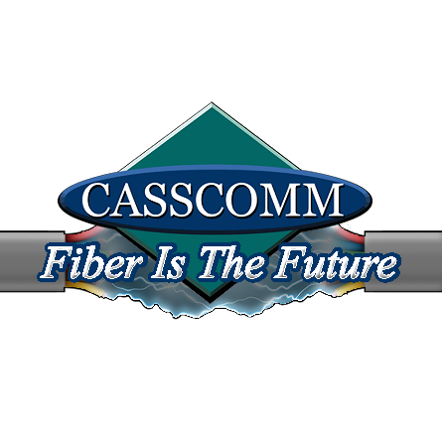
CASSCOMM
Casey French
217-452-4120
Casey.french@casscabletv.com
For Immediate Release: (03-19-20)

CASSCOMM offering to keep customers connected during COVID-19

Virginia IL, 03/19/2020 In order to help their communities stay connected and follow social distancing recommendations, CASSCOMM announced that it is following the “Keep Americans Connected” Pledge that reads as follows: ”Given the coronavirus pandemic and its impact on American society, our company pledges for the next 60 days to: (1) not terminate services to any residential or small business customers because of their inability to pay their bills due to the disruptions caused by the coronavirus pandemic; (2) waive any late fees that any residential or small business customers incur because of their economic circumstances related to the coronavirus pandemic; and (3) open its Wi-Fi hotspots to any American who needs them.”
CASSCOMM will be offering their basic speed internet package to residents who are not current customers at a rate of $9.95 a month for 3 full months. A list of active hotspots can be found on the website at www.casscomm.com. Casey French, CASSCOMM’s marketing and PR Director, stated “We are aware that our broadband services will be a powerful tool toward social distancing during the COVID-19 pandemic. CASSCOMM understands our community members are relying on our services during this nationwide crisis.”
CASSCOMM has offered high quality services to its customers since 1898 and is a family owned business, providing services for over a hundred and twenty years. CASSCOMM offers Cable TV, Internet and Telephone services to thirty-two communities and is currently upgrading its facilities to offer Fiber to the Home. For more information about CASSCOMM, please visit their website at www.casscomm.com or call 800.252.1799.
###
If you would like more information about this topic please contact Casey French Marketing and PR Director for CASSCOMM at 1-800-252-1799 or caseyfrench@casscomm.com

