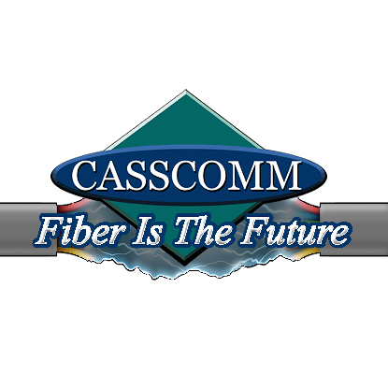
CASSCOMM
Casey French
Casey.french@casscabletv.com
For Immediate Release: (04-17-20)

CASSCOMM: Keeping Our Schools & Communities Connected
During this time of need, CASSCOMM, like many other communication companies, wants to be there to help its communities and families keep their social distance while also being connected. With most of CASSCOMM’s communities working from home and all of the schools closing, E-Learning programs for students became a necessity. CASSCOMM needed to be the number one go-to for all its communities, whether they had broadband services at home or not.
One way that CASSCOMM could help the school districts in their communities was to open all of the hotspots and make sure the ability to service everyone who needed it would be an option, along with putting up new hotspots in more communities.. Since the beginning of the Covid-19 pandemic, CASSCOMM has opened up more than 40 hotspots in its footprint for residents to use.
CASSCOMM made contact with all of the school districts in its coverage area to discuss ways to help out the districts, especially the students once the E-Learning program started. CASSCOMM let the districts know about options for the students, such as a cheap Internet promotion they could sign up for and also a list of hotspots available on the webpage or social media listing.
Most of the districts were a great help in responding and getting broadband to specific families and also had great ideas about where we could put a hotspot in a town. A superintendent whom we speak with regularly had reached out to see about getting hotspots placed in some of the more rural communities in that school district. With his help and ideas, CASSCOMM was able to put two more hotspots up in those areas. CASSCOMM also added multiple hotspots at local municipalities to help residents and students stream content while also feeling comfort being at a police or fire station.
CASSCOMM has offered high quality services to its customers since 1898 and is a family owned business, providing services for over a hundred and twenty years. CASSCOMM offers Cable TV, Internet and Telephone services to thirty-two communities and is currently upgrading its facilities to offer Fiber to the Home. For more information about CASSCOMM, please visit their website at www.casscomm.com or call 800.252.1799.
###
If you would like more information about this topic please contact Casey French Marketing and PR Director for CASSCOMM at 1-800-252-1799 or caseyfrench@casscomm.com

