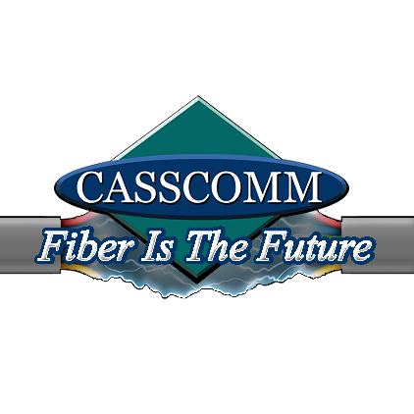

CASSCOMM
Casey French
217-452-4120
Casey.french@casscabletv.com

FOR IMMEDIATE RELEASE

CASSCOMM brings reliable services to South Jacksonville

[[Virginia IL, 8/26/2020] CASSCOMM is known for its reliable and local services of broadband, Cable Tv and telephone services throughout Central Illinois. CASSCOMM is excited to bring fiber optic services to the residents of South Jacksonville. The new fiber optic services will give everyone in the village, residents and businesses, the ability to obtain speeds of up to 1 gigabyte of fiber optic services that they have not been able to receive yet, along with tv and telephone as well. CASSCOMM has partnered with the village to help provide better services to the municipalities. Residents can already see construction crews in the village. Residents will be notified during the construction process on updates and progress of the build.Once the process is close to completion, we will start reaching out to residents and businesses to schedule installations.

With this hard-economic crisis we are currently under and the economy taking a different turn, we see many schools and businesses working remotely. CASSCOMM believes our services will provide residents with the reassurance to be able to connect virtually from home for work or school, if needed.
CASSCOMM has offered high quality services to its customers since 1898 and is a family owned business, providing services for over a hundred and twenty years. CASSCOMM offers Cable TV, Internet and Telephone services to thirty-two communities and is currently upgrading its facilities to offer Fiber to the Home. For more information about CASSCOMM, please visit their website at www.casscomm.com or call 800.252.1799.
###
If you would like more information about this topic please contact Casey French Marketing and PR Director for CASSCOMM at 1-800-252-1799 or caseyfrench@casscomm.com

