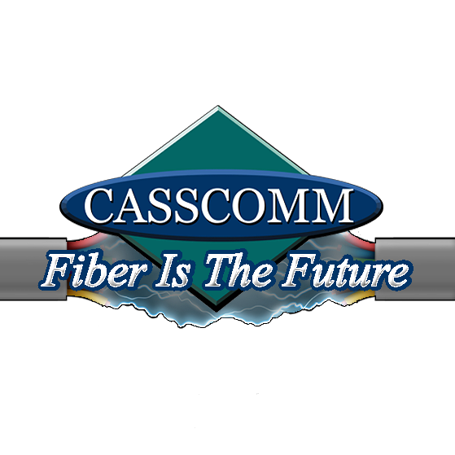
CASSCOMM
Casey French
217-452-4120
Casey.french@casscabletv.com
08.13.21
CASSCOMM ready to start Fiber to the Home in Beardstown

Virginia IL, 08/13/21 CASSCOMM will soon start construction in Beardstown, IL to upgrade their current coax system to Fiber to the Home services. This will allow the Beardstown residents the ability to get symmetrical speeds up to one Gigabyte. Many Beardstown businesses currently have the ability to receive fiber optic services and we are now excited to begin connecting residents. The fiber optic services will allow residents new symmetrical speeds and also let them take advantage of the new “CASSCOMM TV” service. This new platform offers a crisper image, a smaller digital cable box, and even cloud DVR ability. CASSCOMM will also offer 2 free cable boxes per house at no charge when fiber services are installed. Beardstown residents will see CASSCOMM and American Fiber Construction crews working on the upgrade. American Fiber crews have been assisting CASSCOMM in other communities to upgrade our systems. Casey French CASSCOMM’s marketing and public relations Director stated, “We are thrilled to start this upgrade in Beardstown. This is one of our larger communities and it continues to grow. Our services will continue to support Beardstown, as technology advances and the need to stay connected is a priority now more than ever. Fiber optics are a great thing for our growing, local communities.”
CASSCOMM has offered high quality services to its customers since 1898 and is a family owned business, providing services for over a hundred and twenty years. CCMI offers Cable TV, Internet and Telephone services to thirty-two communities and has started rebuilding its communities to offer Fiber to the Home. For more information about CASSCOMM, please visit their website at www.casscomm.com or call 800.252.1799.
###
If you would like more information about this topic please contact Casey French Marketing and Pr Director for CASSCOMM at 1-800-252-1799 or caseyfrench@casscomm.com

