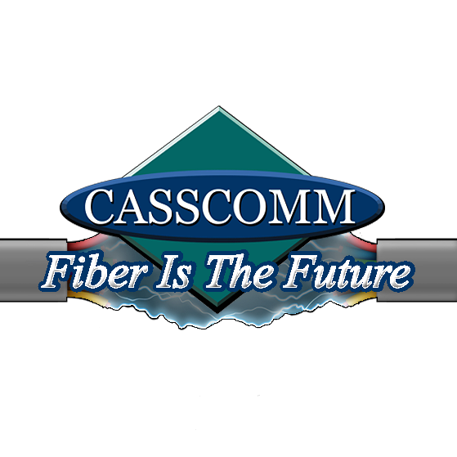
CASSCOMM
Casey French
217-452-4120
Casey.french@casscabletv.com
CASSCOMM ready to start Fiber to the Home in Manito
Virginia IL, 04/13/22] CASSCOMM has recently start construction in Manito, IL to upgrade their current coax system to Fiber to the Home services. This will allow the Manito residents the ability to get symmetrical speeds up to one Gigabyte. Manito businesses currently can or are able to receive fiber optic services and now we are excited to begin connecting residents. The fiber optic services will allow residents new symmetrical speeds and also let them take advantage of the new “CASSCOMM TV” service. This new platform offers a crisper image, a smaller digital cable box, and even cloud DVR ability. Residents will see CASSCOMM and American Fiber Construction crews working on the upgrade. American Fiber crews have been assisting CASSCOMM in other communities to upgrade our systems.
CASSCOMM has offered high quality services to its customers since 1898 and is a family owned business, providing services for over a hundred and twenty years. CCMI offers Cable TV, Internet and Telephone services to thirty-two communities and has started rebuilding its communities to offer Fiber to the Home. For more information about CASSCOMM, please visit their website at www.casscomm.com or call 800.252.1799.
###
If you would like more information about this topic please contact Casey French Marketing and PR Director for CASSCOMM at 1-800-252-1799 or caseyfrench@casscomm.com

