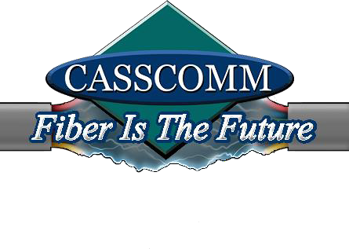
CASSCOMM
Casey French 217-452-4120
Casey.french@casscabletv.com

For Immediate Release: (07-27-22)

CASSCOMM’s Owner Gerald E. Gill Passes

Virginia IL, 07/27/22 CASSCOMM is saddened to announce the recent passing of founder and Chairman of the Board Gerald E. Gill.
In the early 1960’s Mr. Gill answered the call to return home to Virginia to manage his family’s business- Cass County Telephone Company (CCTC). Seeing the value of what was then a new technology, Cass Community Antenna Television, Inc. (CATV) was formed in 1965 to serve Beardstown, Illinois, with what was to become cable television service. CCTC and CATV have evolved into CASSCOMM which provides telephone, television, long distance, and internet service to over 30 communities in central Illinois.
Mr. Gill was a true pioneer in the telecommunications industry with success in building, purchasing, upgrading, and selling cable television systems nationwide along with his many other business investments and ventures. Gerald actively participated in every aspect of the business until his passing.
He leaves a legacy to his son, Gerald S. Gill, current President of CASSCOMM, and his family.
###
If you would like more information about this topic please contact Casey French Marketing and PR Director for CASSCOMM at 1-800-252-1799 or caseyfrench@casscomm.com

