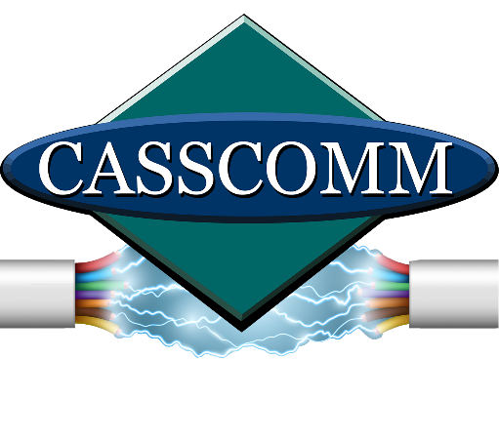
CASSCOMM
Casey French
217-452-4120
Casey.french@casscabletv.com
10/25/22
High Speed Fiber Optics coming to Pleasant Plains

Virginia IL, 10/25/22] CASSCOMM is continuing construction in Pleasant Plains, IL to upgrade their current coax system to Fiber to the Home services. Pleasant Plains businesses currently have the option to receive fiber optic services and CASSCOMM is now excited to begin connecting residents. The fiber optic services will allow residents the ability to have gigabyte symmetrical speeds (equal download and upload speeds). Also with this fiber upgrade CASSCOMM will launch a new TV platform called “CASSCOMM TV”. This new platform offers a crisper image, a more compact digital box, a streaming app, and even cloud DVR ability.
Over the next 3 to 4 months Pleasant Plains residents will see CASSCOMM and American Fiber construction crews working on the upgrade. American Fiber crews have been assisting CASSCOMM in their other communities to upgrade their systems from coax to fiber optics. Casey French CASSCOMM’s Marketing and Public Relations Director stated, “We are thrilled to start this upgrade in Pleasant Plains and offer the residents this great service. As technology advances and grows, the need to stay connected is an important priority now more than ever. Fiber optics is a necessity that our communities need not only to help them grow with new business adventures, but also help the current residents have the ability to work from home, stream, gaming, and more.”
CASSCOMM has offered high quality services to its customers since 1898 and is a family owned business, providing services for over a hundred and twenty years. CCMI offers Cable TV, Internet and Telephone services to thirty-two communities and has started rebuilding its communities to offer Fiber to the Home. For more information about CASSCOMM, please visit their website at www.casscomm.com or call 800.252.1799.
###
If you would like more information about this topic please contact Casey French Marketing and Pr Director for CASSCOMM at 1-800-252-1799 or caseyfrench@casscomm.com

