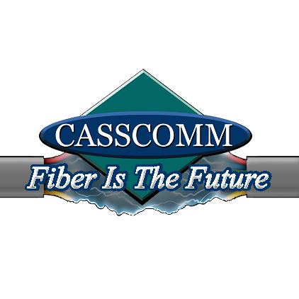

CASSCOMM
Casey French
217-452-4120
Casey.french@casscabletv.com

FOR IMMEDIATE RELEASE

CASSCOMM Bringing Reliability & High-Speed Internet to Murrayville, Illinois

Virginia IL, April 11, 2023 CASSCOMM is well known for its reliable fiber optic broadband services and being able to connect many homes in Central Illinois to the internet, and now CASSCOMM is excited to bring fiber optic services to the residents of Murrayville Illinois. This new fiber optic service will give residents and businesses there the ability to obtain speeds of 1 Gigabit and higher symmetrical download and upload speeds. CASSCOMM will also offer VoIP (Voice Over Internet Protocol) home phone services, & IPTV (Internet Protocol Television). This TV service will offer all the local channels in addition to, premium movie channels and sports network channels with a clear crisp HD viewing experience. Murrayville residents may already notice construction crews in their neighborhood. CASSCOMM will keep the community informed on the stages of construction and when installations will be close and or ready. Casey French, CASSCOMM Marketing and Public Relations Director stated, “We are excited to bring our fiber optic services to Murraryville and we know our future customers will be excited to have this reliable product in their homes as well!”

ABOUT CASSCOMM: Based in Virginia IL, CASSCOMM has offered high quality services to its customers since 1898. It is a family-owned business, providing services for over a hundred and twenty years. CASSCOMM offers cable TV, Internet and Telephone services to 33 communities and is currently upgrading its facilities to offer Fiber to the Home (FTTH).

###
For more information about CASSCOMM, please visit our website at www.casscomm.com or call 800.252.1799.If you would like more information about this topic please contact Casey French Marketing and PR Director for CASSCOMM at 1-800-252-1799 or caseyfrench@casscomm.com

