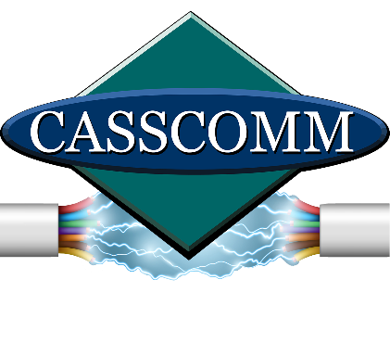
CASSCOMM
Casey French
217-452-4120
Casey.french@casscabletv.com
For Immediate Release: (07/10/23)

CASSCOMM celebrates 125 years of locally owned business
Virginia IL, (July 10, 2023) CASSCOMM, a leading provider of communications in central Illinois, is excited to share that the company is celebrating its 125th year in business and connecting people, businesses, and communities. Such a significant milestone showcases CASSCOMM’s commitment to providing reliable and innovative services to its customers.

In 1898, CASSCOMM began its long and successful journey. William McKinley was President of the United States, 22 years after Alexander Graham Bell successfully received a patent for the telephone. In 1898, CASSCOMM then known as Cass Telephone Co. was granted a franchise as Virginia and Little Indian Telephone Company.

The telephone wires ran from the community of Little Indian to Virginia, IL, providing telephone service within the city limits. The construction wires were strung along roadsides, and attached to any stable device available, such as trees, poles, sheds and whatever else they could attach to.

CASSCOMM is a six-generation family-run business now headed by great great grandson President and CEO Sam Gill. CASSCOMM has witnessed and contributed to the evolution of technology and communication services throughout its long history. CASSCOMM’s expertise and dedication have helped shape the industry for a century and a quarter. Since 1898 CASSCOMM has grown its name and services to be a local household staple that customers can rely on without question.

Over its entire life, CASSCOMM has offered reliable landline telephone services to its customers and still has many communities with landline home phones today.

In 1965, Gerald Gill Sr. launched Cass Cable TV services, offering 12 local channels in its coverage areas. Today, CASSCOMM is still a TV provider, offering customers HD channels over a modern fiber optic network.

In 1996, CASSCOMM took a chance on 54k dial-up Internet access, not knowing where it would lead. With more than 18,000 customers today, this move in 1996 turned out to be a wise choice by the company.

In 2018, CASSCOMM and its board of directors made the decision to be proactive in the broadband world and start a plan to upgrade all of its communities from coaxial cable to fiber optics and connect everyone to Fiber To The Home (FTTH). Today, CASSCOMM has completed more than over 75% of its upgrades in its community footprint and will be done by the end of 2024.
Sam Gill President and CEO of CASSCOMM said “As the company’s sixth-generation President, I am thrilled to carry forward the rich legacy and values that have defined our company over the years. With the recent surge in demand for access to reliable high speed fiber Internet access, we are entering a new era as a telecommunications provider, focusing on expanding our broadband capabilities, while still continuing to enhance our cable TV offerings, and provide state-of-the-art telephone services”.
In celebration of its 125th anniversary, CASSCOMM is expressing gratitude to its loyal customers, employees, and community partners who have supported us throughout the years, by offering 4 months of free fiber Internet to 125 lucky customers. As CASSCOMM embarks on its next chapter of its journey, the company extends its heartfelt thanks to all those who have been a part of CASSCOMM’s success story. CASSCOMM is excited about the future and it looks forward to serving its communities for years to come!

CASSCOMMs current footprint includes 34 communities in 9 counties. CASSCOMM provides services to more than 18,000 customers. CASSCOMM is still centrally located in Virginia IL and offers local technician and customer service help to all its communities.

###
If you would like more information about this topic please contact Casey French Marketing and PR Director for CASSCOMM at 1-800-252-1799 or caseyfrench@casscomm.com

