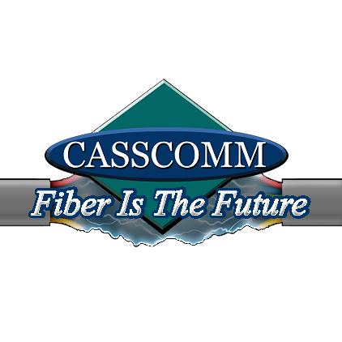

CASSCOMM
Casey French
217-452-4120
Casey.french@casscabletv.com

FOR IMMEDIATE RELEASE

CASSCOMM connects Murrayville, Illinois to fiber optics

Virginia IL, October 4, 2023 Murrayville Illinois now has the ability to say they have fast, reliable internet and connected by CASSCOMM. CASSCOMM has finished construction and is now connecting residents to fiber optics. CASSCOMM recently had a ribbon cutting ceremony in the community with a local food truck, giveways and representatives there to assist the residents on what CASSCOMM will be offering the community. CASSCOMM is well known for its reliable fiber optic broadband services and being able to connect many homes in Central Illinois to the internet, and now CASSCOMM is excited to bring fiber optic services to the residents of Murrayville Illinois. This new fiber optic service will give residents and businesses there the ability to obtain speeds of 1 Gigabit and higher symmetrical download and upload speeds. CASSCOMM offers fiber optic broadband, VoIP (Voice Over Internet Protocol) home phone services, & IPTV (Internet Protocol Television). This TV service will offer all the local channels in addition to, premium movie channels and sports network channels with a clear crisp HD viewing experience. Casey French, CASSCOMM Marketing and Public Relations Director stated, “We are excited to start connecting our fiber optic services in Murraryville and we know the customers will be excited to have this reliable product in their homes as well, if they arent already signed up and connected!”

ABOUT CASSCOMM: Based in Virginia IL, CASSCOMM has offered high quality services to its customers since 1898. It is a family-owned business, providing services for over a hundred and twenty years. CASSCOMM offers cable TV, Internet and Telephone services to 33 communities and is currently upgrading its facilities to offer Fiber to the Home (FTTH).

###
For more information about CASSCOMM, please visit our website at www.casscomm.com or call 800.252.1799.If you would like more information about this topic please contact Casey French Marketing and PR Director for CASSCOMM at 1-800-252-1799 or caseyfrench@casscomm.com

