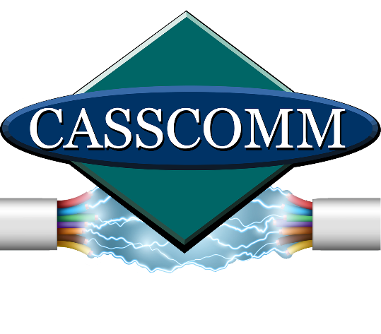

CASSCOMM
Casey French
217-452-4120
Casey.french@casscabletv.com

FOR IMMEDIATE RELEASE

CASSCOMM bringing “Fiber To The Home” to Griggsville IL

Virginia IL, February 8, 2024, CASSCOMM is well known for its reliable fiber optic broadband services and being able to connect many homes in Central Illinois to the internet, and now CASSCOMM is excited to announce they are bringing fiber optic services to the residents of Griggsville. This new fiber optic service will give residents and businesses the ability to obtain speeds of 1 Gigabit and higher with symmetrical download and upload speeds. CASSCOMM will also offer VoIP (Voice Over Internet Protocol) home phone services, & IPTV (Internet Protocol Television). This TV service will offer all the local channels in addition to premium movie channels and sports network channels with a clear crisp HD viewing experience. Griggsville residents may already notice construction crews in their neighborhood, as well as have received a letter. CASSCOMM will keep the community informed on the stages of construction and when installations will be ready.

ABOUT CASSCOMM: Based in Virginia IL, CASSCOMM has offered high quality services to its customers since 1898. It is a family-owned business, providing services for over a hundred and twenty years. CASSCOMM offers cable TV, Internet and Telephone services to 34 communities and is currently working tp upgrade all its communities to offer Fiber to the Home (FTTH).

###
For more information about CASSCOMM, please visit our website at www.casscomm.com or call 800.252.1799.If you would like more information about this topic please contact Casey French Marketing and PR Director for CASSCOMM at 1-800-252-1799 or caseyfrench@casscomm.com

