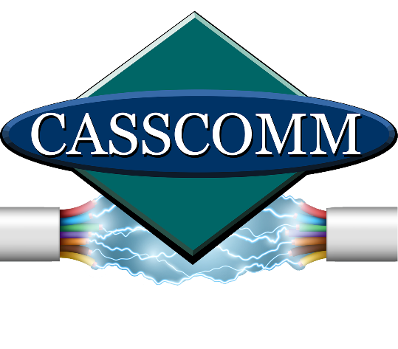

CASSCOMM
Casey French
217-452-4120
Casey.french@casscabletv.com

FOR IMMEDIATE RELEASE

CASSCOMM’s early thinking makes fiber upgrade faster moving

Virginia, IL (April 24, 2024) - CASSCOMM is on the final stretch of completing its fiber upgrade! The CASSCOMM fiber install team is currently working in a few remaining towns, including Griggsville, Illinois. Once the upgrade is complete, Griggsville will have a faster and more reliable internet connection, putting it on the map with high-speed internet!

When CASSCOMM originally built the system and installed the first customer in 2010, it operated using radio frequency over glass (RFoG), a fiber and coax hybrid. The outside plant was built with fiber optics and coax was used inside the house.

Fast forward to today, with fiber being the latest technology, CASSCOMM’s forward thinking and planning provided the ability to connect residents much quicker, saving on construction and installation time. Since the system backbone was already fiber, it made the upgrade much faster to install and connect houses by switching neighborhoods over one at a time. CASSCOMM plans to have all neighborhoods switched over by June 1, 2024, leaving time for cleanup and late installs.

ABOUT CASSCOMM: Based in Virginia, Illinois, CASSCOMM has offered high-quality services to its customers since 1898. It is a family-owned business, providing services for over a hundred and twenty years. CASSCOMM offers cable TV, Internet and Telephone services to 34 communities and is currently working to upgrade all its communities to offer Fiber to the Home (FTTH). “

###
For more information about CASSCOMM, please visit our website at www.casscomm.com or call 800.252.1799. If you would like more information about this topic, please contact Casey French, Marketing and PR Director for CASSCOMM, at 1-800-252-1799 or caseyfrench@casscomm.com

